NEWS LETTER, DETAILED ACTIVITY OF LAST 5 YEARS

GOVERNMENT MEDICAL COLLEGE PATIALA
DEPARTMENT OF TUBERCULOSIS & CHEST DISEASES
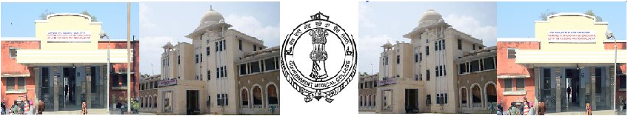
March, 2014

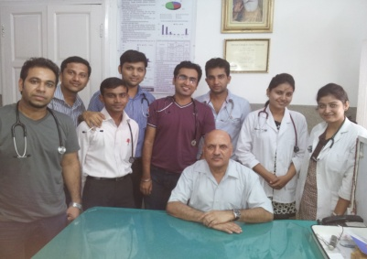
- Government Medical College, Patiala, is the second oldest medical college in the state of Punjab, in India. It was founded in October 1953 by Patiala and East Punjab States Union government. With its attached 900 bed Rajindra hospital + 121 bed TB hospital is one of the largest health institutions in the region.
- Dept. Of Tuberculosis and Chest diseases is established in Chest & TB Hospital near Lahori Gate , just a stone throw distance from Bus Stand & Railway Station .
- With 121 beds and recently started R.I.C.U it is handling hundreds of patients daily in systematic and kind manner
Dr.AP Kansal Prof Head cum DMS
TB Hospital Patiala with
Post graduate students

- Considering the specialized nature of diagnostic and therapeutic procedures required for management of respiratory diseases and an intimate relationship with other medical specialties.
- The Institute provides treatment of tuberculosis as well as non tubercular respiratory diseases in a separate respiratory disease wing and ICU. The hospital is also dedicated to services of BPL & Poor patients by providing free facilities to them Life line drug store of the institute is providing medicines at a price much lower then the market rate
"Find TB. Treat TB. Working together to eliminate TB."
HOSPITAL DATA (Last 5 years data)
 | 2009 | 2010 | 2011 | 2012 | 2013
OPD | 43156 | 43678 | 46001 | 46899 | 48492 | 12.36%
INDOOR | 2106 | 2302 | 2713 | 3380 | 3631 | 72.41%
X RAY | 24122 | 17895 | 19685 | 23000 | 23114
USER CHARGES(RUPEES) | 74,49934 | 83,53,44 | 9699935 | 1618513 | 2088288 | 18%
BED OCCUPANCY | 89.4% | 89% | 91% | 107% | 104.9% | 15.5%
DEATH RATE | 9.3% | 8.7% | 6.8% | 6.0% | 5%
RED CROSS SALE(RUPEES) | 29,46,465 | 39,69,906 | 59,13,973 | 77,03,587 | 85,53,888 | 190%

- In Last 5 years there has been increase in patient inflow in both outdoor and indoor patients which have increased 12.36% and 72.41% respectively
- User charges have shown growth of 180%
- There has been increase in bed occupancy by 15.5%
- Patient friendly services and utmost care has resulted in fall of death rate from 9.3% to 5% .
- Drug store with in hospital premised run by Red Cross district society has shown 190% increase in sales.
SERVICES AT OFFER

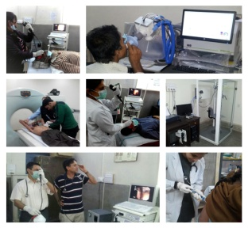
- Services offered through the Pulmonary Medicine, Patiala specialty include:
- Outpatient clinics for evaluation and treatment of various lung conditions
- Hospital inpatient services for evaluation and treatment of various lung conditions
- Intensive care services for management and treatment of the critically ill
- Bronchoscopic diagnosis and treatment
- Access to various diagnostic and treatment protocols
- Pulmonary Function Laboratory
- Pulmonary Rehabilitation Program
- Training programs for Pulmonary and Critical Care specialists
- Increasingly number of patients are diagnosed with tuberulosis with stateof art laboratory with LED anD fluorescent Microscopes.

Number of patients availed OT procedures during period 2009-2013 | Number of Spirometries performed during period 2009-2013
Year Diagnostic Pleaural Tap Therapeutic Pleural Tap FNAC Lymph Node Intercostals Chest Tube Insertion  2009 127 48 19 66  2010 250 73 29 52  2011 166 80 39 51  2012 167 127 37 62  2013 186 160 31 69 | Number of Bronchoscopies performed during period 2009-2013

RECENT HAPPENINGS
- Digital X ray which was long due has been started with help of District Red Cross Society there by bettering the quality reducing the burden ON 26/11/2013
- Best in class Fibro optic bronchoscope, Spirometery and plethysmograph installed in May 2013 by then Minister for Medical education Punjab Honourable Sh.Chunni Lal Bhagaton 26/7/2013
- IRL lab has been inaugrated by principal secretary to govt of Punjab dept of health and family welfare. Sh Satish Chandra ji on 24/3/12
- DOTS plus ward for category 4 treatment of multi drug resitant cases from 9 districts around Patiala has been started on 6/2/12
- Only dept in medical college to launch its own website www.chestgmcpatiala.weebly.com
- Water pumping machine has been installed. Solving years old problem of water logger during rains.
- Ward No. 6, renovated and repaired, along with new electrical fittings.
- Respiratory ICU has been started.
- Apart from excelling in patient car and administration department has touch new heights academically, with 8 index journal publication. 88 national, 23 international research paper presentation in various conferences in last 5 years.
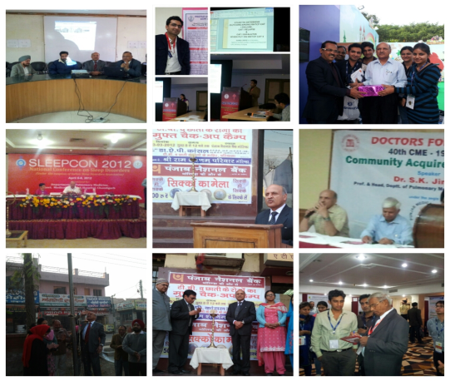

Hospital for Chest Diseases and Tuberculosis  (Department of Pulmonary Medicine,GMC , Patiala)  A premier institute of Pulmonary Medicine, Tuberculosis and Critical Care in North India devoted to patient care and education.  Address : TB and Chest Diseases Hospital  Near Lahori Gate, Patiala 147001  Phone : 0175-2220268  FAX : 0175-2220268 | Email: chestgmcpatiala@gmail.com  Prof Head cum DMS  Dr. AP Kansal  e-mail : dramritpalkansal@yahoo.co.in

Professor :  Dr. A.P. Kansal  Dr. Jai Kishan  Dr. B.K. Kapoor  Associate Professor  Dr. Vishal Chopra  Dr. Urvinder Pal Singh  Assistant Professor  Dr. Surinder Pal Singh  Dr. Kiranjit Kaur  Epidemiologist  Dr. Ashrafjeet Chahal  Microbiologist  Dr. Yogesh Chand | 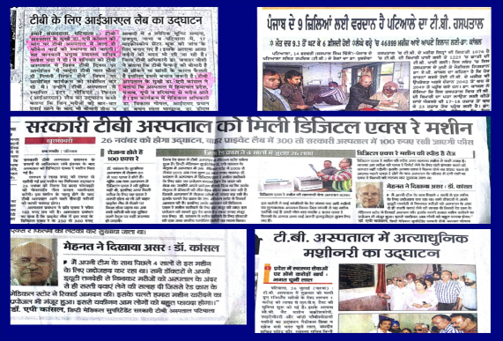 | PG  Dr. Gopal Chawla  Dr. Naresh Kumar  Dr. Komaldeep  Dr. Kalpesh Patel  Dr. Aditi  Dr. Don Gregory  Dr. Shiyaz Mohd.  Dr. Kamaldeep  Dr. Vidhu Mittal  Dr. Sunil Kumar  Dr. Nancy Garg  Dr. Daksh Jhim  Dr. Hitesh Jain  Dr. Prabhleen  Dr. Kiran N

